

**LAB RECORD**

**(23CSE111)**

**OBJECT ORIENTED PROGRAMMING**

**CH.SC.U4CSE24124 – Maddu Raahithya Yadav**

**BACHELOR OF TECHNOLOGY**

IN

**COMPUTER SCIENCE AND ENGINEERING**

AMRITA VISHWA VIDYAPEETHAM

AMRITA SCHOOL OF COMPUTING



**AMRITA VISHWA VIDYAPEETHAM**

**AMRITA SCHOOL OF COMPUTING, CHENNAI**

**BONAFIDE CERTIFICATE**

This is to certify that the Lab Record work for **23CSE111- Object Oriented Programming** Subject submitted by CH.SC.U4CSE24124 – Maddu Raahithya Yadav in “Computer Science and Engineering” is a Bonafide record of the work carried out under my guidance and supervision at Amrita School of Computing, Chennai.

This Lab examination held on

Internal Examiner 1 Internal Examiner 2

|  |  |  |
| --- | --- | --- |
| **S.NO** | **TITLE** | **PAGE.NO** |
| **1**. | **BANK MANAGEMENT SYSTEM** |  |
|  | a)Use case Diagram | 5 |
|  | b) Class Diagram | 6 |
|  | c) Sequence Diagram | 7 |
|  | d) Object Diagram | 8 |
|  | e)State Diagram | 8 |
| **2**. | **COLLEGE MANAGEMENT SYSTEM** |  |
|  | a) Use Case Diagram | 9 |
|  | b) Class Diagram | 10 |
|  | c) Sequence Diagram | 11 |
|  | d) Object Diagram | 12 |
|  | e)State Diagram | 12 |
| **3.** | **BASIC JAVA PROGRAMS** |  |
| a) | Program to display details of a student by input. | 13-14 |
| b) | Printing Pattern by taking input from user. | 14-15 |
| c) | To check if the given letter is vowel or not | 15-16 |
| d) | Sum of digits of a number | 16-17 |
| e) | Reversing a number | 17-18 |
| f) | Fibonacci series | 18-19 |
| g) | Deposit and Withdrawal from a Bank Account | 19-20 |
| h) | Grade of student by input | 20-21 |
| i) | Area of circle | 21-22 |
| j) | Simple Calculator | 23-24 |

**UML DIAGRAMS**

**1)BANK MANAGEMENT SYSTEM**

**1)a)Use case diagram** 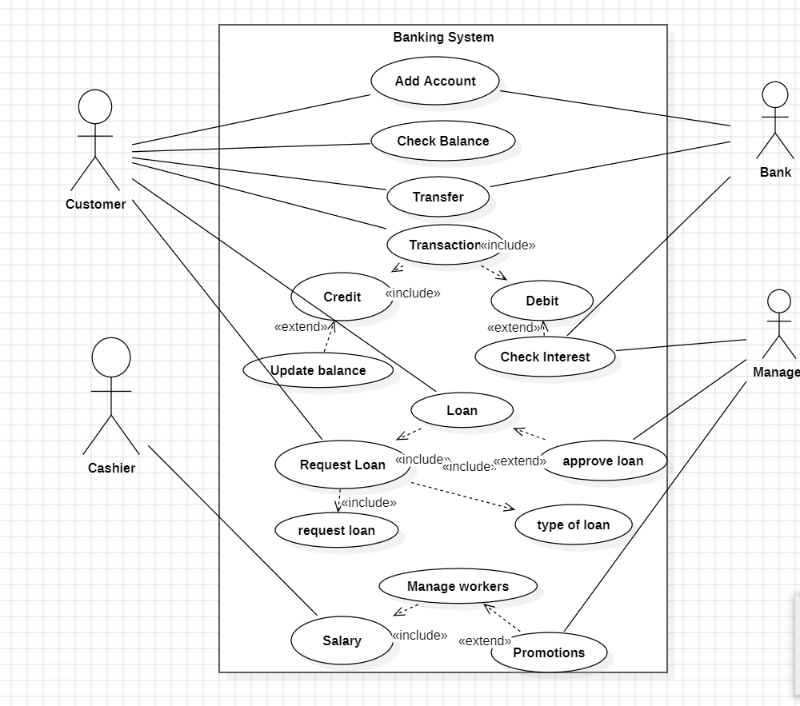

**1b)class diagram**

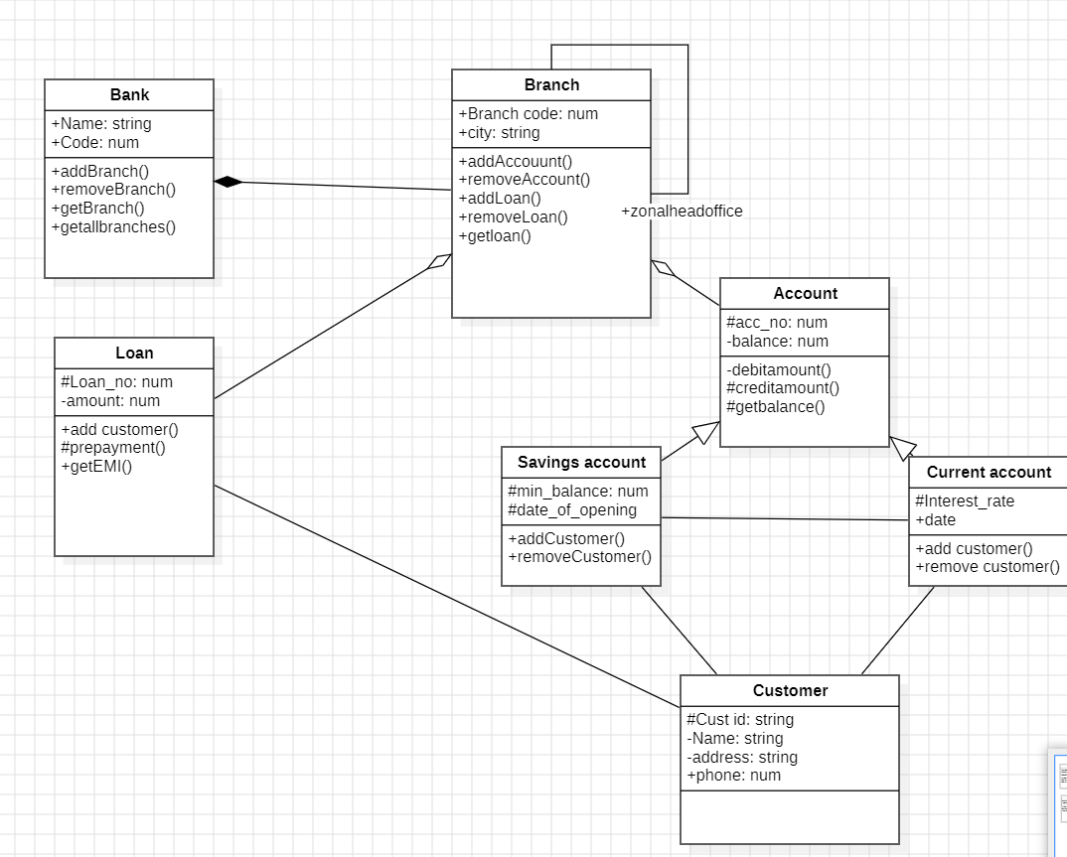

**1c)sequence diagram**

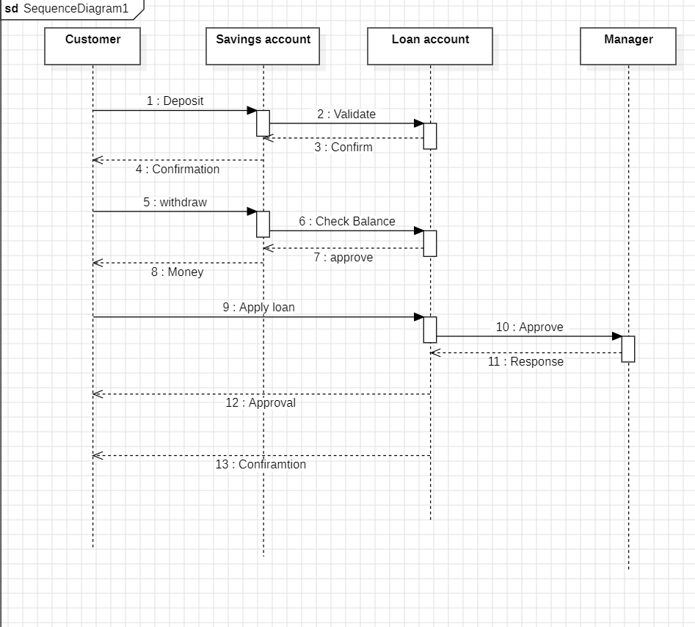

**1d)object diagram**

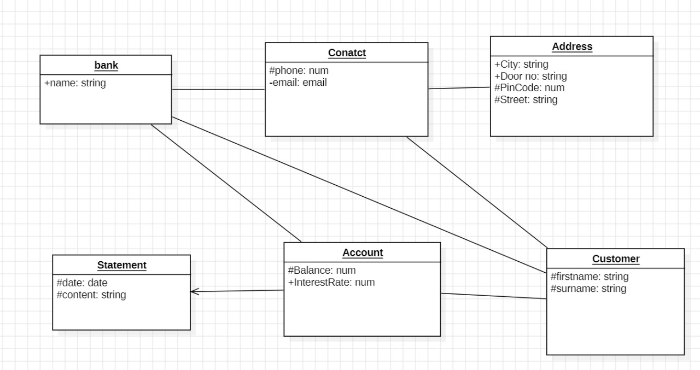

**1e)state diagram**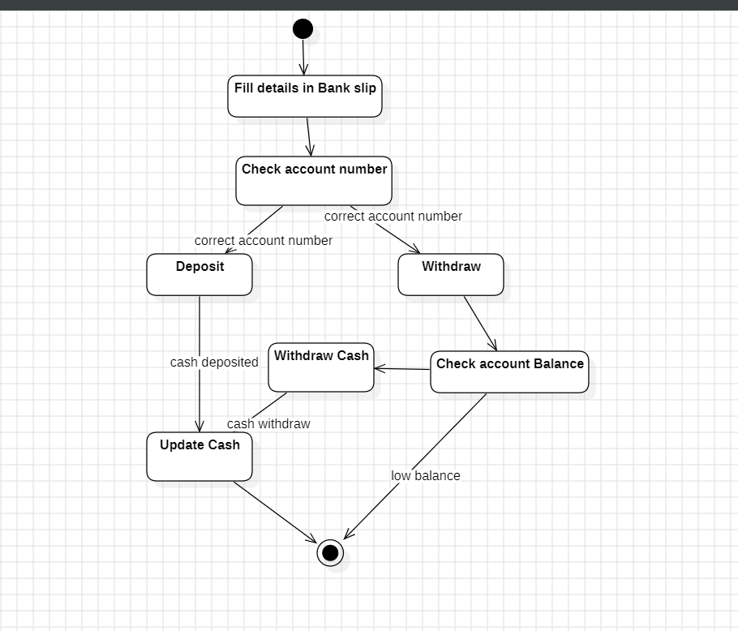

**2.COLLEGE MANAGEMENT SYSTEM**

**2a)usecase diagram**

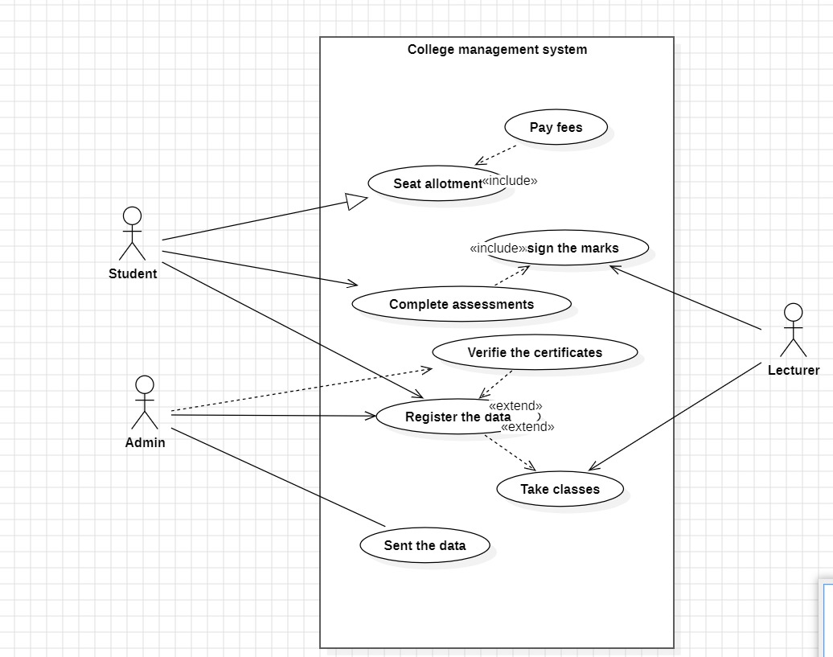

**2b)class diagram**

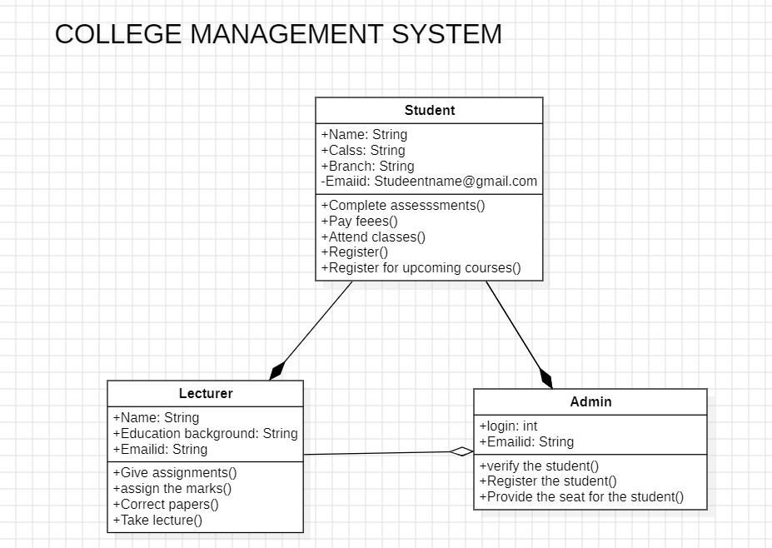

**2c)sequence diagram**

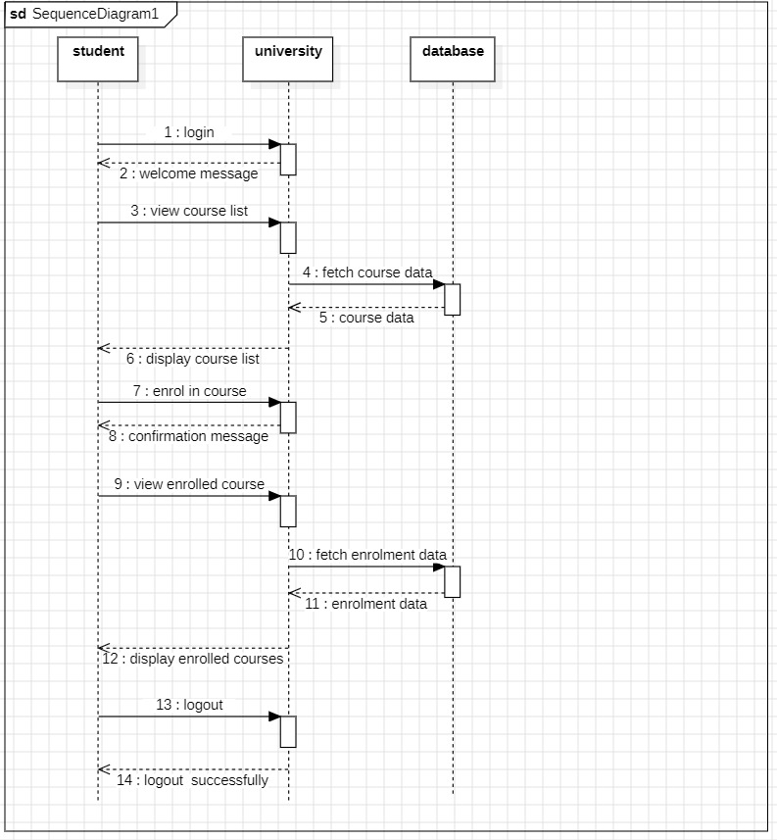

**2d)object diagram**

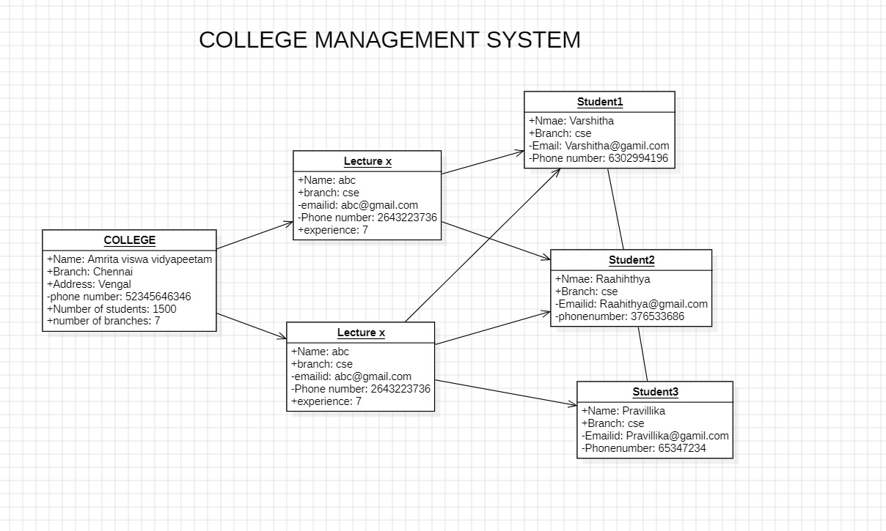

**2e)state diagram**

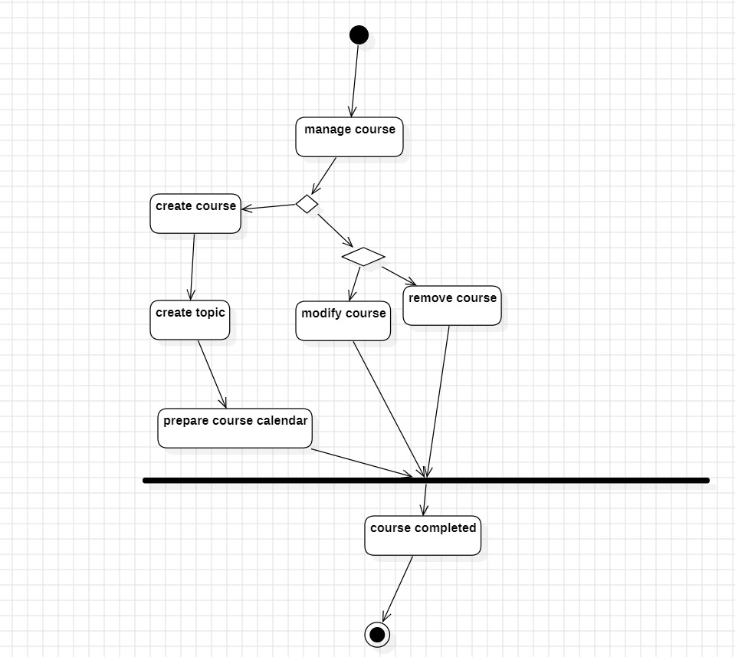

**3.Basic Java Programs**

**a) AIM:** To write a Program to display details of a student by input

**CODE:**

import java.util.Scanner;

public class Student {

String name;

int age;

public void displayInfo() {

String status = (age >= 18) ? "Adult" : "Minor";

System.out.println("Name: " + name);

System.out.println("Age: " + age);

System.out.println("Status: " + status);

}

public static void main(String[] args) {

Scanner scanner = new Scanner(System.in);

Student student1 = new Student();

System.out.print("Enter first student's name: ");

student1.name = scanner.nextLine();

System.out.print("Enter first student's age: ");

student1.age = scanner.nextInt();

scanner.nextLine(); // Consume newline

student1.displayInfo();

scanner.close();

}

}

**OUTPUT:**

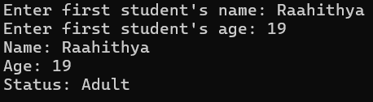

**b)AIM:** To Print Pattern by taking input from user.

**CODE:**

import java.util.Scanner;

public class PrintPattern {

public static void main(String[] args) {

Scanner scanner = new Scanner(System.in);

System.out.print("Enter the number of rows: ");

int rows = scanner.nextInt();

for (int i = 1; i <= rows; ++i) {

for (int j = 1; j <= i; ++j) {

System.out.print("* ");

}

System.out.println(); }

scanner.close();

}

}

**OUTPUT:**

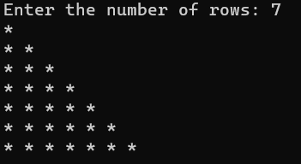

**c)AIM:** To check if the given letter is vowel or not

**CODE:**

import java.util.Scanner;

public class VowelConsonent {

public static void main(String[] args) {

Scanner scanner = new Scanner(System.in);

System.out.print("Enter a character: ");

char ch = scanner.next().charAt(0);

// Checking if it's a vowel or consonant

if (ch == 'a' || ch == 'e' || ch == 'i' || ch == 'o' || ch == 'u' ||

ch == 'A' || ch == 'E' || ch == 'I' || ch == 'O' || ch == 'U') {

System.out.println(ch + " is a vowel.");

} else if (Character.isLetter(ch)) {

System.out.println(ch + " is a consonant.");

} else {

System.out.println(ch + " is not a valid letter.");

}

scanner.close();

}

}

**OUTPUT:**



**d)AIM:** To find the Sum of digits of a number

**CODE:**

import java.util.Scanner;

public class SumOfDigits {

public static void main(String[] args) {

Scanner scanner = new Scanner(System.in);

System.out.print("Enter a number: ");

int num = scanner.nextInt();

int sum = 0;

int originalNum = num;

while (num > 0) {

int digit = num % 10;

sum += digit;

num /= 10;

}

System.out.println("Sum of digits of " + originalNum + " is: " + sum);

scanner.close();

}

}

**OUTPUT:**

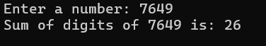

**e)AIM:** To reverse a number

**CODE:**

import java.util.Scanner;

public class ReverseNumber {

public static void main(String[] args) {

Scanner scanner = new Scanner(System.in);

System.out.print("Enter a number: ");

int num = scanner.nextInt();

int reverse = 0;

for (; num > 0; num /= 10) {

int digit = num % 10;

reverse = reverse * 10 + digit; }

System.out.println("Reversed Number: " + reverse);

scanner.close();

}

}



**f)AIM:** To find Fibonacci series.

**CODE:**

import java.util.Scanner;

public class Fibonacci {

public static void main(String[] args) {

Scanner scanner = new Scanner(System.in);

System.out.print("Enter the number of terms: ");

int n = scanner.nextInt();

int first = 0, second = 1;

System.out.println("Fibonacci Series up to " + n + " terms:");

for (int i = 1; i <= n; i++) {

System.out.print(first + " ");

int next = first + second;

first = second;

second = next;

}

scanner.close();

}

}

**OUTPUT:**

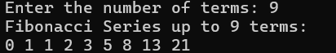

**g)AIM:** Deposit and Withdrawal from a Bank Account

**CODE:**

class BankAccount {

String accountHolderName;

double balance;

BankAccount(String name, double initialBalance) {

accountHolderName = name;

balance = initialBalance;

}

void deposit(double amount) {

balance += amount;

System.out.println("Deposited: " + amount + ", New Balance: " + balance);

}

void withdraw(double amount) {

if (amount > balance) {

System.out.println("Insufficient balance!");

} else {

balance -= amount;

System.out.println("Withdrawn: " + amount + ", New Balance: " + balance);

}

}

public static void main(String[] args) {

BankAccount account = new BankAccount("Alice", 1000);

account.deposit(500);

account.withdraw(300);

account.withdraw(1500);

}

}

**OUTPUT:**

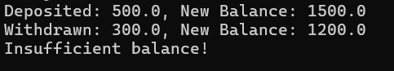

**h)AIM:** To display grade of a student.

**CODE:**

import java.util.Scanner;

public class StudentGrade {

public static void main(String[] args) {

Scanner scanner = new Scanner(System.in);

System.out.print("Enter the student's marks (0-100): ");

int marks = scanner.nextInt();

if (marks >= 90) {

System.out.println("Grade: A+ (Excellent)");

} else if (marks >= 80) {

System.out.println("Grade: A (Very Good)");

} else if (marks >= 70) {

System.out.println("Grade: B (Good)");

} else if (marks >= 60) {

System.out.println("Grade: C (Satisfactory)");

} else if (marks >= 50) {

System.out.println("Grade: D (Pass)");

} else {

System.out.println("Grade: F (Fail)");

}

scanner.close();

}

}

**OUTPUT:**



**i)AIM:** To find area of a circle.

**CODE:**

import java.util.Scanner;

public class CircleArea {

public static void main(String[] args) {

Scanner scanner = new Scanner(System.in);

System.out.print("Enter the radius of the circle: ");

double radius = scanner.nextDouble();

double area = Math.PI * radius * radius;

System.out.println("The area of the circle is: " + area);

scanner.close();

}

}

**OUTPUT:**

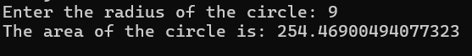

**j)AIM:** To write a program for simple calculator

**CODE:**

import java.util.Scanner;

public class Calculator {

public static void main(String[] args) {

Scanner scanner = new Scanner(System.in);

System.out.print("Enter first number: ");

double num1 = scanner.nextDouble();

System.out.print("Enter second number: ");

double num2 = scanner.nextDouble();

System.out.print("Choose an operation (+, -, *, /): ");

char operator = scanner.next().charAt(0);

double result;

switch (operator) {

case '+':

result = num1 + num2;

System.out.println("Result: " + result);

break;

case '-':

result = num1 - num2;

System.out.println("Result: " + result);

break;

case '*':

result = num1 * num2;

System.out.println("Result: " + result);

break;

case '/':

if (num2 != 0) {

result = num1 / num2;

System.out.println("Result: " + result);

} else {

System.out.println("Error! Division by zero is not allowed.");

}

break;

default:

System.out.println("Invalid operator! Please choose +, -, *, or /.");

}

scanner.close();

}

}

**OUTPUT:**

